ASSIGNMENT 2

CSA0593

-192324289

RAKINA S

QUESTION:

database to manage tasks, projects, users, and deadlines.

- Model tables for tasks, projects, users, and deadlines.

- Write stored procedures for assigning and updating tasks.

- Implement triggers to update project progress and task completion status.

- Write SQL queries to generate project timelines and user task performance.

ANSWER:

A database to manage tasks, projects, users, and deadlines can be designed to optimize project management and team collaboration. The database can consist of several tables, including Users, Projects, Tasks, and Deadlines. The Users table can store information about each user, such as their name, email, and role. The Projects table can store information about each project, such as its name, description, and start date. The Tasks table can store information about each task, such as its name, description, and due date. The Deadlines table can store information about each deadline, such as its date and time.

The relationships between these tables can be established using foreign keys. For example, each task can be associated with a project, and each project can be associated with multiple tasks. Similarly, each user can be associated with multiple projects, and each project can be associated with multiple users. The database can also include additional tables to store information about task assignments, task status, and project progress.

To manage deadlines, the database can include a scheduling system that sends reminders and notifications to users about upcoming deadlines. The database can also include a reporting system that generates reports about project progress, task completion rates, and user productivity. By using a database to manage tasks, projects, users, and deadlines, teams can streamline their workflow, improve collaboration, and increase productivity.

FLOWCHART:

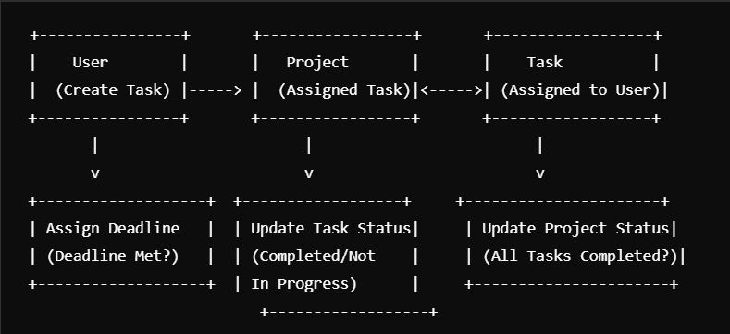

1.TABLE DESIGN

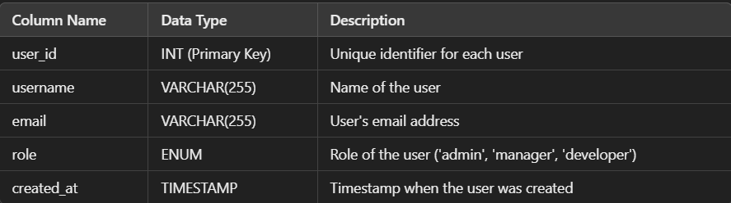

2.PROJECT TABLE

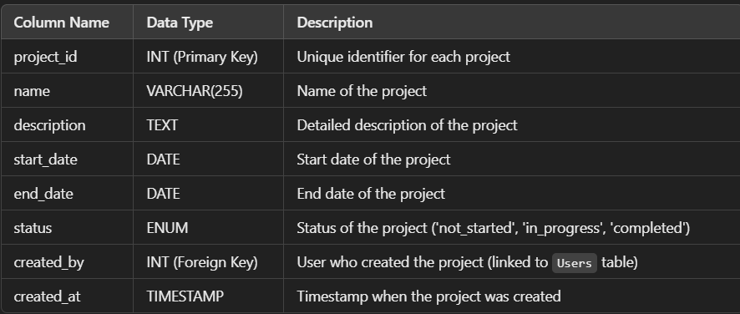

3.TASKS TABLE

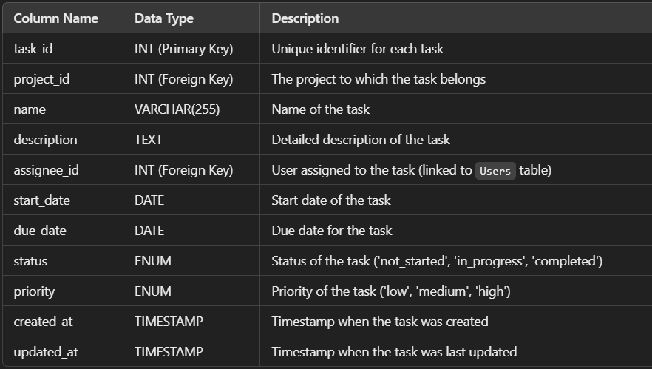

2.DEADLINES

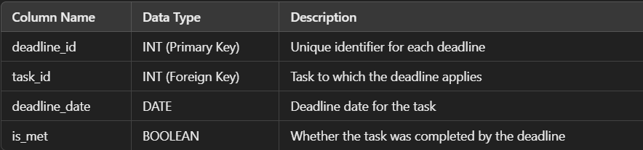

STORED PROCEDURES:

ASSIGN TASK TO A USER

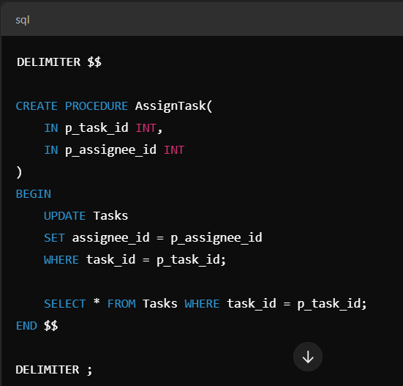

UPDATE TASK STATUS

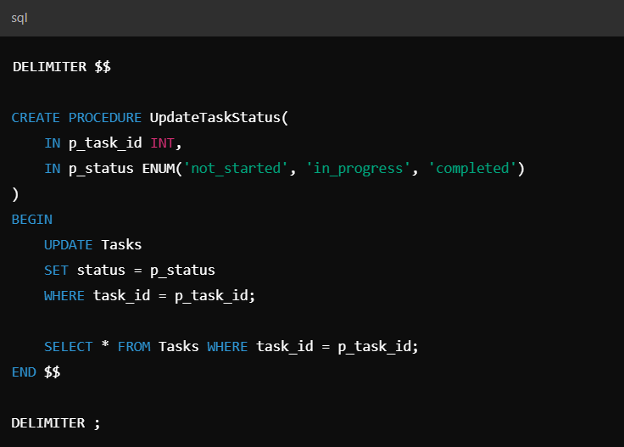

SQL QUERIES:

TO GENERATE PROJECT TIMELINES

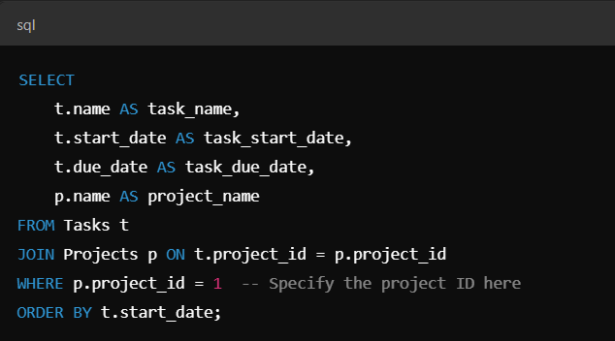

USER TASK PERFORMANCE

